**Importing Data to a Firestore Database**

**Overview**

Twelve years ago, Lily started the Pet Theory chain of veterinary clinics. The Pet Theory chain has expanded rapidly over the last few years. However, their old appointment scheduling system is not able to handle the increased load, so Lily is asking you to build a cloud-based system that scales better than the legacy solution.

Pet Theory's Ops team is a single person, Patrick, so they need a solution that doesn't require lots of ongoing maintenance. The team has decided to go with serverless technology.

Ruby has been hired as a consultant to help Pet Theory make the transition to serverless. After comparing serverless database options, the team decides to go with [Cloud Firestore](https://firebase.google.com/docs/firestore). Since Firestore is serverless, capacity doesn't have to be provisioned ahead of time which means that there is no risk of running into storage or operations limits. Firestore keeps your data in sync across client apps through real-time listeners and offers offline support for mobile and web, so a responsive app can be built that works regardless of network latency or Internet connectivity.

In this lab you will help Patrick upload Pet Theory's existing data to a Cloud Firestore database. He will work closely with Ruby to accomplish this.

Architecture

This diagram gives you an overview of the services you will be using and how they connect to one another:

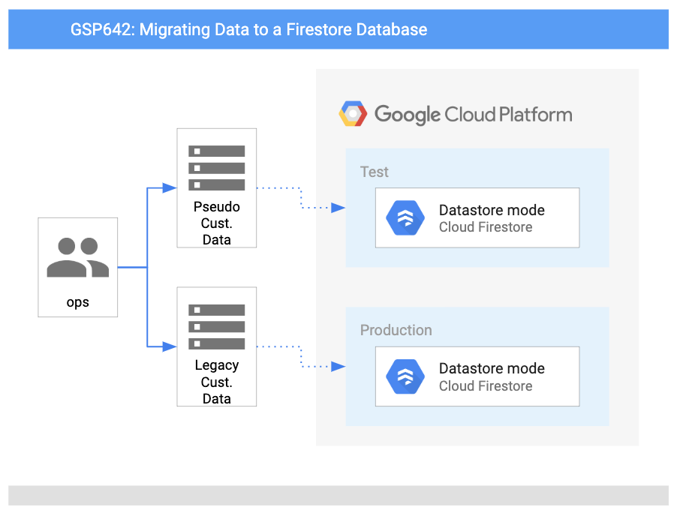

**Objectives**

In this lab, you will learn how to:

* Set up Firestore in Google Cloud.
* Write database import code.
* Generate a collection of customer data for testing.
* Import the test customer data into Firestore.
* Patrick's task is to upload Pet Theory's existing data to a Cloud Firestore database. He will work closely with Ruby to accomplish this goal. Ruby receives a message from Patrick in IT...

|  |  |
| --- | --- |
| Patrick  *Patrick, IT Administrator* | Hi Ruby,  Our first step in going serverless is creating a Firestore database with Google Cloud. Can you help with this task? I am not very familiar with setting this up.  Patrick |
| Ruby  *Ruby, Software Consultant* | Hey Patrick,  Sure, I would be happy to help with that. I'll send you some resources to get started, let's get in touch once you're done creating the database.  Ruby |

**Note:**Both modes are high performing with strong consistency, but they look different and are optimized for different use cases.

* *Native Mode* is good for letting lots of users access the same data at the same time (plus, it has features like real-time updates and direct connection between your database and a web/mobile client
* *Datastore Mode* puts an emphasis on high throughput (lots of reads and writes).
* On completion of the task, Ruby emails Patrick...

|  |  |
| --- | --- |
| Ruby  *Ruby, Software Consultant* | Hey Patrick,  Great work setting up the Firestore database! To manage database access, we will use a Service Account that has been automatically created with the necessary privileges.  We are now ready to migrate from the old database to Firestore.  Ruby |
| Patrick  *Patrick, IT Administrator* | Hey Ruby,  Thanks for the help, setting up the Firestore database was straightforward.  I hope the database import process will be easier than it is with the legacy database, which is quite complex and requires a lot of steps.  Patrick |

Patrick sends a message to Ruby...

|  |  |
| --- | --- |
| Patrick  *Patrick, IT Administrator* | Hi Ruby,  My manager would like to begin migrating the customer data to the new Firestore database.  I have exported a CSV file from our legacy database, but it's not clear to me how to import this data into Firestore.  Any chance you can lend me a hand?  Patrick |
| Ruby  *Ruby, Software Consultant* | Hey Patrick,  Sure, let's set up a meeting to discuss what needs to be done.  Ruby |

|  |  |
| --- | --- |
| Patrick  *Patrick, IT Administrator* | Hi Ruby,  The code I use for the legacy database is pretty basic, it just creates a CSV ready for the import process. Anything I need to download before I get started?  Patrick |
| Ruby  *Ruby, Software Consultant* | Hi Patrick,  I would suggest using one of the many @google-cloud Node packages to interact with Firestore.  We should then only need to make small changes to the existing code since the heavy lifting has been taken care of.  Ruby |

|  |  |
| --- | --- |
| Patrick  *Patrick, IT Administrator* | Hi Ruby,  I think it would be better if we don't use customer data for testing. We need to maintain customer privacy, but also need to have some confidence that our data import script works correctly.  Can you think of an alternative way to test?  Patrick |
| Ruby  *Ruby, Software Consultant* | Hey Patrick,  Fair point, Patrick. This is a tricky area, as customer data may include personal identifiable information, also called PII.  I'll share some starter code with you to create pseudo customer data. We can then use this data to test the import script.  Ruby |